Bike Discounters
“Support Your Local Bike Shop”
Shirt Order Form
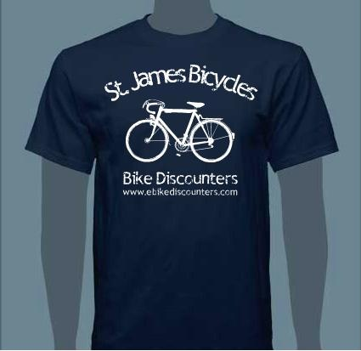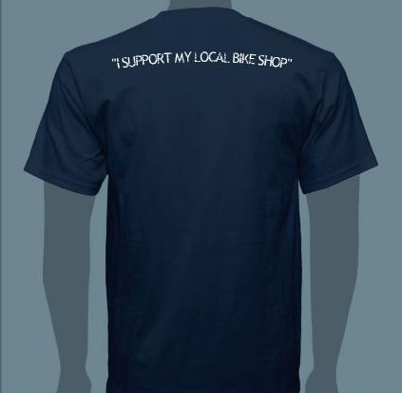

Name:_______________________________________________________________________

Address:_____________________________________________________________________

Phone:________________________________Email:__________________________________

T Shirt Sizes & Quantities
S_________M_________L_________XL_________2XL_________3XL_________

YXS_________YS_________YM_________YL_________YXL_________

Hoodie Sizes & Quantities
S_________M_________L_________XL_________2XL_________3XL_________

YXS_________YS_________YM_________YL_________YXL_________

Total T Shirts:_______$15ea:________Total Hoodies________$35ea.___________________

Order Date:__________Total___________________Pick Up Date:_______________________

